**Cynthia Ackrill, MD**

NCNAELA

April 16, 2016

**Speaker, Leadership Coach, Stress Expert** [**http://www.cynthiaackrill.com**](http://www.cynthiaackrill.com)

**828.777.9730**

**Goal =** access to the state of FLOW –ease of focus, creativity, cognitive agility, energized



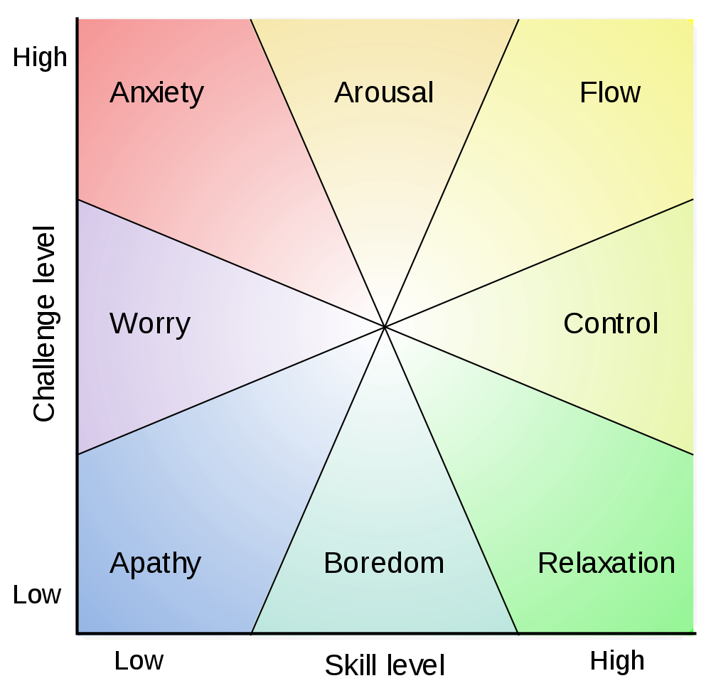 Mikhail Csikszentmihalyi

<http://www.amazon.com/Flow-Psychology-Experience-Perennial-Classics/dp/0061339202>

**Sad, sad statistics:**

1/3 of lawyers would choose another profession (docs have you beat ;-))

Highest suicide rate of all professions

20.6% report problematic ETOH use (7-10% general population), but actually 36.4% qualify as problem drinkers (2016 ABA)

3.6 x more likely to suffer from depression – 28%

19% struggle with anxiety

Young lawyers at highest risk

Alcohol specific:

Excess drinking estimated costs- $223.5b in economic and healthcare costs

2014 World Cancer report increase chance with 1-2 drinks/day: mouth, pharynx/larynx, esophagus, colon, rectum, liver, breast, pancreas

Light drinking may lower risk for stroke, and may be anti-atherogenic and anti- inflammatory

**Most important thing to know: there is help out there!** But today let’s back up from the outcomes to explore why so many are unhappy and look for ways to support better outcomes- thriving attorneys.

Yes, there are genetic/brain differences that predispose an individual for addiction or psychological issues, but that is not the whole answer. There are contexts- cultures, behaviors, experiences, situations, influences- that make these struggles more or less likely to be expressed.

**The set up:**

Unrealistic expectations – the perfect storm

Pessimism – overly developed negativity, hyper-vigilant (about lack of safety)

Perfectionism – no room for vulnerability- this begets shame, no reward of deep career satisfaction

“Type A culture”- Lack of basic self-care, health practices

Disconnection- from purpose, people, sense of accomplishment

Premise- Belief in lack of control

Lack of empathy

Shame – fear of vulnerability

**The better questions**:

* ***How can you make choices in thoughts and behaviors that would support your best self?***
* ***How can you set yourself up to be happy, healthy, productive, connected, deeply satisfied?***
* ***How can you contribute to making the profession more supportive of healthier choices for all?***

**Energy management** trumps time management.

**Physical**- hydration/nutrition/sleep/rest/conditioning

**Mental**- focus (distraction management)/flexibility/creativity/stimulation/rest (processing) **Emotional**- mood regulation/mental health

**Spiritual**- connection to others/meaning/purpose

**Increase your access to flow and your best state:**

1. **Awareness**- know your energy state (train yourself to check in), know how you operate best, know your strengths and values, know what motivates you (your why)

Values exercise: <http://www.cynthiaackrill.com/resources/>

Strengths exercise: [http://www.authentichappiness.sas.upenn.edu/questionnaires.aspx 1](http://www.authentichappiness.sas.upenn.edu/questionnaires.aspx)

Take the VIA Signature Strengths Questionnaire- it’s free! There is a children’s version as well—powerful and fun to do as a family or team. You may also enjoy [Strengthsfinder](http://strengths.gallup.com/110440/about-strengthsfinder-20.aspx)1

1. **Create habits that renew your energy**- physically, mentally, emotionally, and spiritually
2. **Practice mindset** – 5 C’s and a G: Clear, Calm, Curious, Courageous, Compassionate (esp. with yourself!), and Grateful

This involves changing your relationship with stress to get more positive and proactive- Awareness, Tools to shift in the moment, Strategies to create less in the future

**BRAIN 101**

**Brain’s priorities**:

* Safety – reptilian/early mammalian wiring- will override all other priorities
* Satisfaction – drives to meet basic needs
* Connection – once safe and satisfied, connection is key to higher function

**Frontal Lobe Executive functions-** impaired by chronic stress

* Attention span (focus control)
* Perseverance
* Judgment
* Impulse control
* Modify complex behaviors
* Organization
* **Self-monitoring** and supervision
* Problem solving
* Critical thinking, creativity, flexibility
* Forward thinking
* Learning from experience
* Ability to feel and express appropriate emotions
* Regulating all other brain systems
* Empathy

Your brain on alcohol

* Alters the structure and function of neurons in the dorsomedial striatum, a part of the brain known to be important in goal-driven behaviors
* Activates reward pathway in nucleus accumbens- but heavy use leads to less activation
* Creates more reward to risky behavior (activation with risky choice and dampening response to outcomes)
* Faster cognitive and memory decline – problem solving, short-term memory, visuospatial abilities
* Cognitive impairment may make it harder to treat, esp. in first few weeks of abstinence
* 1/3 of users have a mental illness, increased risk of suicide
* Diminished brain size, less dense (less connections) esp. frontal lobe and cerebellum
* Deficiencies in intellectual functioning- not overall intelligence, but

**5 KEY REQUESTS FROM YOUR BRAIN:**

***1. Meet my energy needs first, please!***

**Advanced Needs**:

* Rest
* Movement
* Stimulation/play
* Social connection
* Proactive stress management
* Mindset practice- curiosity, positivity

**Basic Needs:**

* O2
* Water
* Food = nutrition!
* Sleep

***2. Let me do my job with my priorities!***

1. Safety
2. Satisfaction
3. Connection

***3. Motivate me; don’t make me!***

Intrinsic motivation: autonomy, mastery, purpose

Push vs. pull– Willpower myth (should diet)

Inner critic management

Fun factor

Happy management

***4. Make it easy!***

Creating habits = efficiency, energy conservation

Multipurpose

Get obstacles out of my way – like stress!

***5. Use me to change me!***

Don’t just cram me full of content- practice the how of thinking, perceiving.

Practicing mindset is taking back choice.

Develop awareness of what works for you and what doesn’t. Then, play/experiment with small tweaks to see if you can adjust your system toward thriving. Go gently, kindly, and thoughtfully into this- it’s a marathon, not a sprint. It’s continual research and you are the scientist.

And never, ever be afraid to ask for help!!!! There is no shame in being human.

**What works for you? (Energizers)** Include motivators, behaviors, habits, triggers for your best states of being.

* What helps you access your peak performance- your most energized and focused state?
* Think about this on a personal level first, then…
* How do organization and culture influences/expectations/practices support your best performance?

**What doesn’t work for you? (Drains)**

* What do you do that sabotages your best performance? (Like cheat sleep, skip meals, let connections go)
* What demotivates you, triggers your stress- personally, in the organization, in the culture?

**How can you find more balance in your energy management?**

**What will you do differently after today?**

What are you committed to experimenting/playing with?

**I will____________________________________________________________________________ __________________________________________________________________________________________________________________________________________________________________**

***Please, never hesitate to reach out*** *with questions, ideas and feedback (I can take it and appreciate it!) We are all in this together, trying to figure out the best way to be happy, healthy, contributing humans.*

*I am here to help. I’d love to have you check out my website (*[*www.cynthiaackrill.com*](http://www.cynthiaackrill.com)*) for more resources or join the conversation on my social media platforms.*

[](https://www.linkedin.com/in/cynthiaackrillmd)[](https://twitter.com/cackrill)[](https://plus.google.com/u/0/+CynthiaAckrill/posts/p/pub)[](https://www.youtube.com/user/ackrillmd)[](https://www.facebook.com/pages/WellSpark/169635033081868)

**THANK YOU, THANK YOU!!!**

Cindi

[cackrill@gmail.com](mailto:cackrill@gmail.com)

828-777-9730

|  |  |  |  |  |
| --- | --- | --- | --- | --- |
|  | ENERGIZERS | | DRAINS | |
| Personal | Organizational/  Cultural | Personal | Organizational/  Cultural |
| PHYSICAL  Sleep/rest/hydration/  nutrition/conditioning |  |  |  |  |
| MENTAL  Focus (vs. distraction)  flexibility/creativity/  stimulation/rest (for processing) |  |  |  |  |
| EMOTIONAL  Mood regulation/  Health |  |  |  |  |
| SPIRITUAL  Meaning/purpose/  connection to others and your why |  |  |  |  |